**PROJECT 4-ADV**

**CODE:**

<html lang="en">

<head>

<meta charset="UTF-8">

<meta name="viewport" content="width=device-width, initial-scale=1.0">

<title>Combined Layout</title>

<link rel="stylesheet" href="https://cdn.jsdelivr.net/npm/swiper@8/swiper-bundle.min.css">

<style>

/* Styles for the initial content */

body {

font-family: Arial, sans-serif;

margin: 0;

padding: 0;

background-color: white; /* Plain white background */

}

.container {

max-width: 1000px;

margin: 0 auto;

padding: 20px;

background-color: rgba(255, 255, 255, 0.8); /* Semi-transparent white background */

border-radius: 10px;

box-shadow: 0 0 20px rgba(0, 0, 0, 0.1); /* Shadow effect */

}

nav {

margin-bottom: 20px;

}

nav a {

text-decoration: none;

color: #333;

margin-right: 20px;

font-weight: bold;

}

.main-content {

text-align: center;

}

h1 {

color: #333;

}

h2 {

color: #555;

margin-bottom: 10px;

}

p {

color: #777;

margin-bottom: 20px;

}

button {

background-color: #007bff;

color: #fff;

border: none;

padding: 10px 20px;

font-size: 16px;

border-radius: 5px;

cursor: pointer;

transition: background-color 0.3s ease;

}

button:hover {

background-color: #0056b3;

}

/* Styles for the slider */

.slider-container {

text-align: center;

margin-top: 50px; /* Adjust spacing */

}

.title {

color: blue;

font-weight: bold;

}

.sample-slider {

width: 70%;

margin: auto;

}

.sample-slider img {

width: 100%;

}

</style>

</head>

<body>

<div class="container">

<nav>

<a href="#">Home</a>

<a href="#">Features</a>

<a href="#">Pricing</a>

<a href="#">Blog</a>

<a href="#">Category</a>

</nav>

<div class="main-content">

<h1>Startup 3</h1>

<h2>Forget About Code</h2>

<p>Startup Framework gives you complete freedom over your creative process — you don't have to think about any technical aspects. There are no limits and absolutely no coding.</p>

<button>Create an Account</button>

</div>

</div>

<div class="slider-container">

<h1 class="title">Hello!! :)</h1>

<h1>A MEMORY OF PICTURES!!!</h1>

<div class="swiper sample-slider">

<div class="swiper-wrapper">

<div class="swiper-slide"><img src="https://images.pexels.com/photos/3945317/pexels-photo-3945317.jpeg?auto=compress&cs=tinysrgb&w=600"></div>

<div class="swiper-slide"><img src="https://images.pexels.com/photos/596134/pexels-photo-596134.jpeg?auto=compress&cs=tinysrgb&w=1260&h=750&dpr=2"></div>

<div class="swiper-slide"><img src="https://images.pexels.com/photos/1683975/pexels-photo-1683975.jpeg?auto=compress&cs=tinysrgb&w=1260&h=750&dpr=2"></div>

<div class="swiper-slide"><img src="https://images.pexels.com/photos/3672355/pexels-photo-3672355.jpeg?auto=compress&cs=tinysrgb&w=1260&h=750&dpr=2"></div>

</div>

<div class="swiper-pagination"></div>

<div class="swiper-button-prev"></div>

<div class="swiper-button-next"></div>

</div>

</div>

<br> </br>

<script src="https://cdn.jsdelivr.net/npm/swiper@8/swiper-bundle.min.js"> </script>

<script>

const swiper = new Swiper('.sample-slider', {

loop: true,

slidesPerView: 2,

centeredSlides: true,

spaceBetween: 20,

autoplay: {

delay: 2000,

},

pagination: {

el: '.swiper-pagination',

},

navigation: {

nextEl: ".swiper-button-next",

prevEl: ".swiper-button-prev",

},

});

</script>

</body>

</html>

**CSS:**

body, html {

margin: 0;

padding: 0;

}

.container {

display: flex;

flex-direction: column;

align-items: center;

justify-content: center;

height: 100vh;

background-image: url('https://images.pexels.com/photos/114979/pexels-photo-114979.jpeg?auto=compress&cs=tinysrgb&w=1260&h=750&dpr=2');

background-size: cover;

background-position: center;

padding: 20px;

}

nav {

display: flex;

justify-content: center; /* Changed this line */

width: 80%; /* Changed this line */

padding-top :20px;

}

nav a {

margin: 10px; /* Added this line */

}

.main-content {

text-align:center;

color:white;

}

h1 {

font-size: 3em; /* Added this line */

}

h2 {

font-size: 2em; /* Added this line */

}

p {

max-width: 600px; /* Added this line */

}

button{

padding :10px ;

border-radius: 50px; /* Added this line */

background-color: blue; /* Added this line */

color: white; /* Added this line */

margin-top: 20px; /* Added this line */

**OUTPUT: 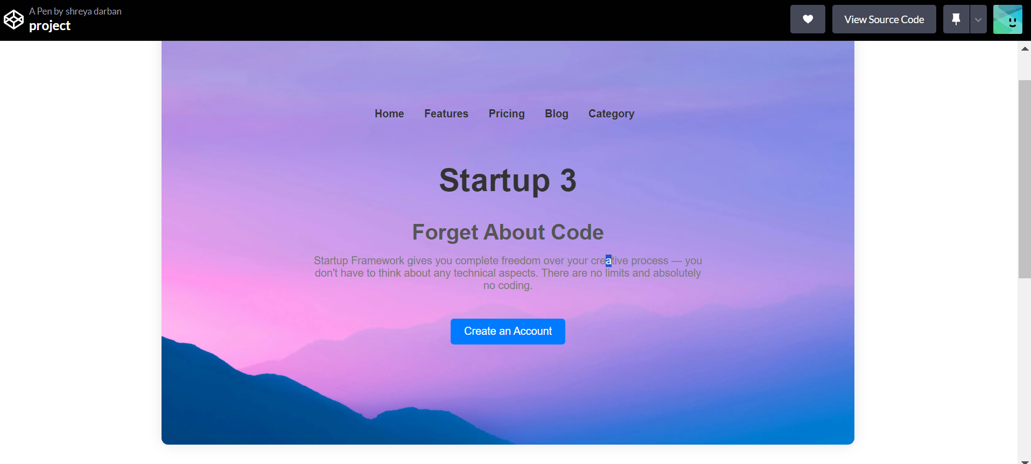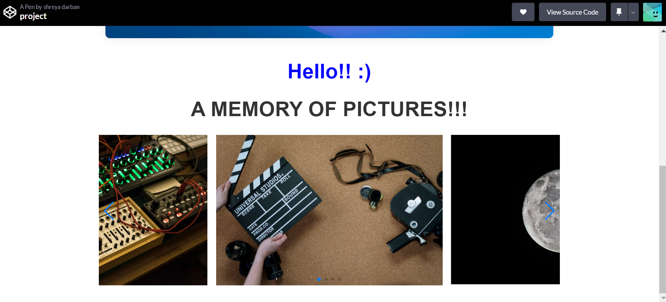 LINK:** https://codepen.io/shreya-darban/full/XWQWebL